**Unit11 How was your school trip?**

Section B (2a-2c)

Reading 教学设计

—Guo Yan

**Learning goals:**

By the end of the class, we’ll be able to:

1. Grasp verbs and description words related to travel activities.

2. Can distinguish some positive words and negative words, and use them in the correct context.

3. Sort out the main content of the diary, and then retell the diary by reading the mind-map.

4. Understand that different people can feel differently about the same thing by reading the two diaries.

**Learning Processes:**

**Step1 Pre-reading**

Lead in: Vocabulary (by using some pictures about my last trip. )

(Different people have different feelings about the same thing. They will use different words to describe.)

【设计意图：通过一些图片描述自己的上一次旅行，导入新知，帮学生扫清部分单词的学习障碍。】

Task: Do Section B 2a

Which words describe good things? Which words describe bad things? And some words can mean both. Give them an example.

(The car is fast. But if you drive too fast, it means dangerous.)

【设计意图：能区分褒义词和贬义词，让学生明白对于同一件事情不同的人可以有不同的看法。】

**Step 2 While-reading**

Task: 1: Fast- reading.

1. Q1: What’s the type of the article? Q2: Which tense was used in it?

2. Play a game (Find out the verbs in the past tense as quickly as possible.)

3. Let Ss read Helen’s and Jim’s diary entries quickly, circle the description wordsand answer the questions.

Q1: When was the school trip?

Q2: Where did they go?

Q3: How did they go there?

Q4: How do they feel about the trip?

when

School trip

.

Jim

Helen

where

How

.

【设计意图：用三个特殊疑问词，帮学生简单提炼文章的主要内容。通过让学生圈出文章的形容词这一活动，上承2a又能为完成2c提供思路】

Task: 2: Careful- reading

1. Do Section B 2c. How do Helen and Jim describe these things?

|  |  |  |
| --- | --- | --- |
|  | Helen | Jim |
| the trip |  |  |
| the train |  |  |
| the museum |  |  |
| the gifts in the gift shop |  |  |

2. Read Helen’s diary again, and answer the questions.

1. What did Helen do in these places?

|  |  |
| --- | --- |
| On the train |  |
| At the museum |  |
| In the gift shop |  |

(2)What did the guide do at the museum?

3.Read Jim’s diary again. Why did Jim think the museum was boring? _____________________________________________________________________

**Step 3 Post-reading**

Task: 1: Complete the mind map together, and then retell the diary.

Beginning

格式

Format）

Body

Ending

Diary

时态

Tense

When and where

Helen’s school trip

What

It was__________________

How

I visited _____on_________

(Jim’s school trip)

I think today’s school trip___________

Beginning

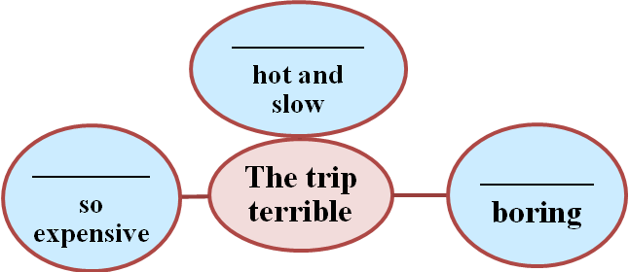

Body

Ending

I didn’t____________________.

【设计意图：通过思维导图理清文章脉络，为复述做准备。】

Task2 Discussion

What can we learn from the diary entries?

(Different people have different feelings about the same thing; we should enjoy our life; be happy every day, etc.)

【设计意图：With a positive attitude to face all kinds of things, looking for their own emotional control methods.引导学生以积极的心态来面对各类事物，寻找适合自己的情绪调控方法。】

**Step4 Homework**

1. Retell the story after class.
2. Use the description words and verbs in the past tense to talk about your trip.

板书设计

Unit11 How was your school trip? Section B (2a-2c)

adj verb

exciting see-saw

lovely learn-learned

expensive can-could

cheap teach-taught

slow buy-bought

fast hear-heard

dark

be interested in

All in all,